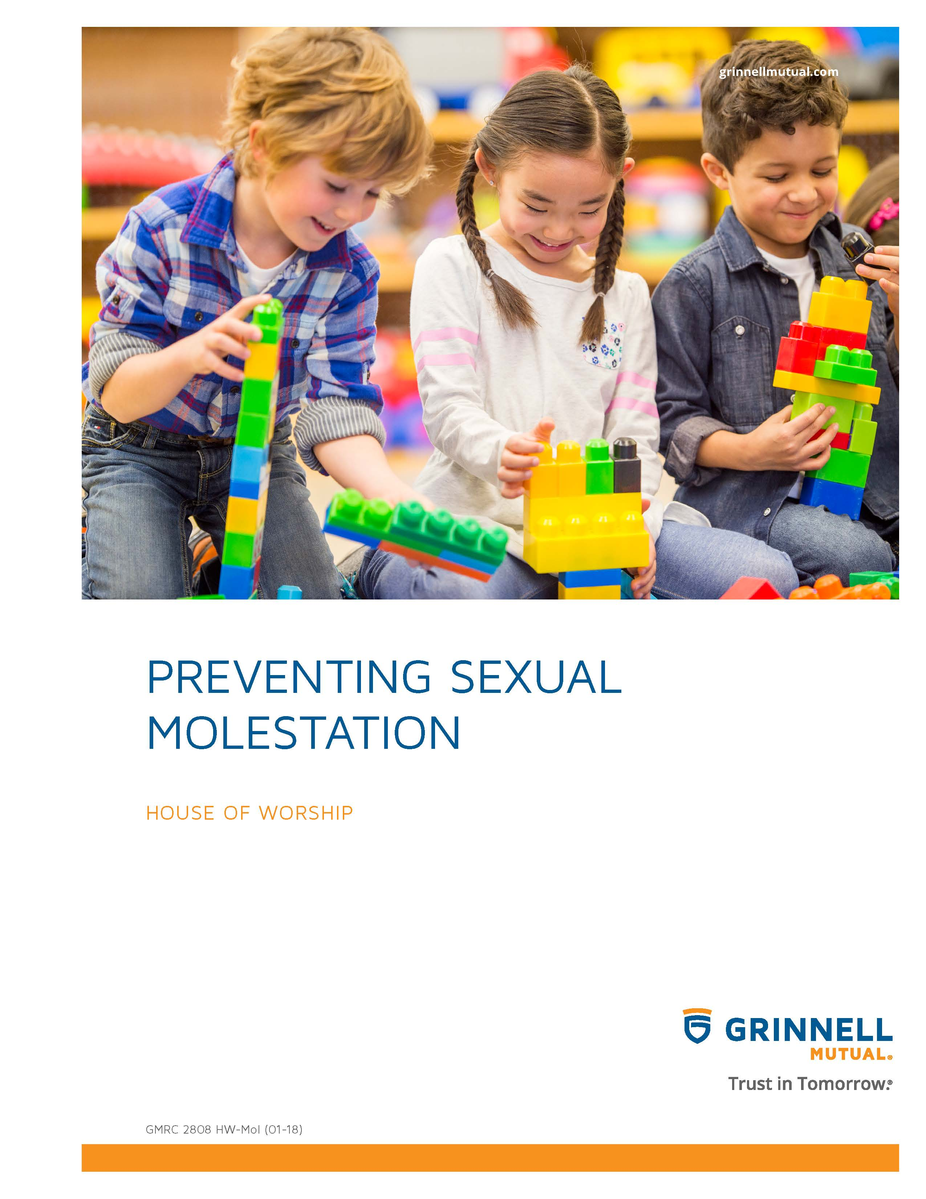

Disclaimer
This booklet has been developed by Grinnell Mutual Reinsurance Company and is for informational purposes only. It was designed to provide reasonably accurate information in regard to the subject matters covered. The information contained herein has been obtained from sources that we believe to be competent and reliable.
Grinnell Mutual Reinsurance Company is aware that this booklet will not fit the operations of all companies. Applicable state/federal statutes must supersede any conflicting statements made or referred to in this booklet.
Grinnell Mutual Reinsurance Company cannot be held responsible or liable for any damages, direct or indirect, which may arise, in part or in whole, from the use of this booklet or from any representation or misrepresentation contained therein. Also, it cannot be assumed that all acceptable safety and health measures are listed in this booklet.

Preventing Sexual Molestation
It is in the best interest of a house of worship and its children/youth to adopt policies, procedures, and practices to assist the house of worship in protecting the children/youth from sexual molestation.
It is the responsibility of the house of worship to educate house of worship leaders, staff, and volunteers in the identification and prevention of sexual misconduct. In many cases, sexual misconduct will violate criminal statutes and may lead to the prosecution and imprisonment of offenders.
The house of worship should establish a policy of zero tolerance for sexual misconduct and should aggressively pursue investigation of reports of misconduct.
The information provided in this document includes items that each house of worship should consider as they adopt procedures. There are some guidelines that can establish clear directions. The information is general and not all inclusive. It is designed to allow each house of worship to expand upon or develop specific content of policies and procedures that can be adopted and implemented according to the religious beliefs and activities of the house of worship.
In August 2004, the Centers for Disease Control (CDC) developed a report designed for representatives of youth-serving organizations who were interested in adopting strategies to prevent child sexual abuse. A group of experts got together to develop the report, these experts included advocates, child sexual abuse researchers, professional supervised prevention resources for organizations and representatives of youth-serving organizations and child sexual abuse programs. A copy of this report can be obtained from the Centers for Disease Control and Prevention, US Department of Health and Human Resources; (800)CDC-INFO or www.cdc.gov/injury.
Because the legal definition of child sex abuse can vary by state, the CDC suggests looking up your state guidelines using the Child Welfare Information Gateway (www.childwelfare.gov/systemwide/laws_policies/
search/index.cfm). In the CDC report, they list 6 key components of child sexual abuse prevention for organizations. The sections are:
1. Screening and selecting employees and volunteers
2. Guidelines on interactions between individuals
3. Monitoring behavior
4. Ensuring safe environments
5. Responding to inappropriate behavior, breaches in policy, and allegations and suspicions of child sexual abuse
6. Training about child sexual abuse prevention
Also, within the CDC report is a list of publications and organizations that provide suggestions for addressing challenges to developing and implementing a strategy to prevent child sexual abuse and to provide tools to help organizations move forward. Houses of worship should consult with legal representation and review state and national laws before adopting and implementing a program on prevention of sexual molestation.
Screening for sexual abuse prevention should be integrated into the house of worship’s general screening and selection process for paid staff and volunteers.
The house of worship should consult with an attorney to insure that their screening and selection policies do not violate Title VII of the Civil Rights Act or other federal or state laws prohibiting discrimination in the workplace.
In deciding who should be screened, do not make exceptions for people you know or have worked with in the past. All existing employees and volunteers, as well as new employees and new applicants, should be screened.
Require applicants to sign a document describing the policies and procedures of your house of worship to demonstrate their understanding and agreement about your child/youth protection policies as well as your policy on prevention of sexual molestation. A written application for staff and volunteers should provide information you need to assess background and interest of the applicants as they relate to the prevention of sexual molestation. Applications should help you determine whether applicants have mature adult relationships, as well as clear boundaries and ethical standards for their conduct with children and youth. The permission form that you use for contacting personal references, for performing criminal background checks, etc. should be developed by your attorney to protect your house of worship from false allegations or other legal issues.
All applicants, both staff and volunteer, should have a personal interview with house of worship leadership and one other person. This interview will provide an opportunity to not only meet applicants, but to determine if they are a good fit for your house of worship and allow you to ask additional questions to screen for sexual abuse risk factors. Ask open-ended questions and encourage discussion and clarify and expand on the applicant’s answers to questions from the written application.
The addresses and contact information for child/youth caregivers (i.e. parents and guardians) should never be released to unauthorized individuals. You should also obtain permission from caregivers for child/youth to participate in certain activities, such as field trips, late night activities, and overnight trips. Also, you should inform caregivers about what their children/youth will be doing and where they will be going. And, you should allow caregivers to have input on what activities or interactions they are comfortable with for their children/youth.
A protocol should be developed so that staff/volunteers are clear about their roles and responsibilities in the prevention of sexual molestation. Staff/volunteers should be prepared to respond immediately to inappropriate or harmful behavior, potential risk situations, and potential boundary violations. These protocols should be enforced so that appropriate actions will follow. Supervisors need to redirect inappropriate behaviors to promote their positive behaviors, confront inappropriate or harmful behaviors, and report these behaviors if necessary.
Your house of worship should develop multiple monitoring methods to get a clear picture of how individuals are interacting with child/youth. These observations could be the use of formal supervision, including regular evaluations or it may be the use of informal supervision, such as including regular and random observations (e.g. checking interactions throughout an activity period and maintain frequent contact with staff/volunteers and child/youth that interact off-site).
In developing your reporting procedures for sexual molestation, consult with your attorney to develop procedures that are in compliance with all local, state and federal laws. You may also want to take a proactive position and partner with child protective services, law enforcement and child advocacy centers (www.nationalcac.org) as opposed to taking a reactive position following allegations that inappropriate/
illegal behavior has occurred.
In responding to an allegation, let child protective services, law enforcement, child advocacy centers and your insurance carrier investigate allegations or suspicions of inappropriate/illegal behavior. Premature investigation by your house of worship staff could hinder efforts by appropriate agencies to conduct their own investigation at a later date. Such action by your staff could result in mental/emotional harm to any child/youth involved in the case.
After an allegation of sexual misconduct has been reported, do not conduct your own investigation, but depending upon the circumstances, it may be appropriate to ask a few clarifying questions of the child/youth or the person making the allegation to adequately report the suspicion or allegation to the authorities. For example, one case reported on by the CDC, a young girl said, “My daddy put his thing in my mouth and it hurt”. When asked what she meant, the child reported that her father had stuck his finger too far into her mouth when attempting to get out a loose tooth. The individual who was speaking with the child at first thought that a report needed to be made, but they slowed down to clarify what had occurred. After doing so, it was clear that no report was needed.
The house of worship should develop an internal records system to track all allegations and suspicions of sexual molestation. These records should be held in confidence and should not be available to those not authorized in the house of worship to review the information. The house of worship should develop policies on how to deal appropriately and responsibly with alleged or convicted offenders if the house of worship decides that it may not be appropriate to revoke membership or employment. One suggestion by the CDC is that the house of worship may want to require limited access agreements in which alleged or convicted offenders can attend the worship service or activity that does not involve children/youth, but may not be involved in any activities specific to children/youth. These individuals may also be required to attend services and activities with a “buddy” or another adult who has agreed to stay with them at all times.
The house of worship needs to reinforce the content of their prevention of sexual molestation program by providing training that is ongoing and not just a one-time event. The education could be in both formal training sessions and informal settings, such as conversations.
For additional information on issues relating to sexual abuse, refer to the book, Church Safety and Security, a Practical Guide, by Robert Cirtin.

